Graduate Certificate
Jewellery, Silversmithing and Related Product
This is an intensive six-month programme that is aimed to familiarise students with the key processes, techniques and terminology specific to the practice of contemporary jewellery and related product. It is an enhancement of your Art and Design degree to enable you to pursue higher study and research in this field.

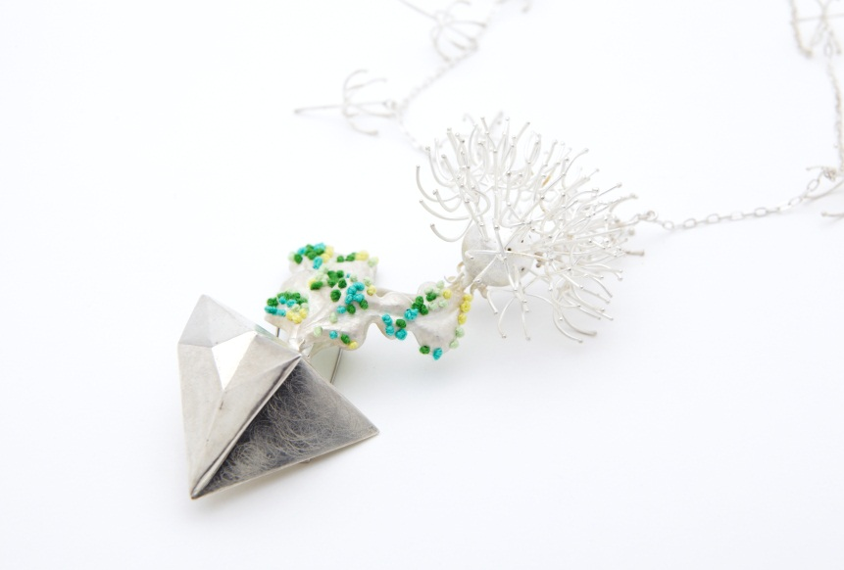
Wen-Miao Yeh
Course aims and objectives
The aims of the course are to:
- Gain experience of, and be able to apply and critically evaluate technical skill and processes specific to, jewellery and related product practice.
- Gain a breadth of knowledge and understanding of critical debate and professional issues particular to the area of contemporary jewellery and related products.
- To develop intellectual thinking and academic skill with an integrated approach to theory and practice in relation to jewellery and related project practice.
- To develop independent reflective working practice and flexible learning in relation to sustaining self-initiated project work of a professional standard in relation to jewellery studio practice.

Zi Ye 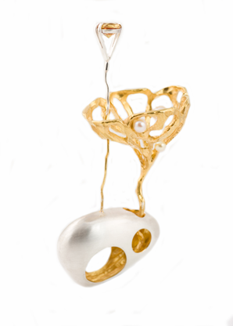
The overall aim of the programme is to allow Art and Design graduates to gain skill, technical experience and to develop a material studio research practice in the specifics of jewellery and related product techniques and processes. The programme will develop an exploratory experimental practice related to the area that is critically reflective.
Students will be given demonstrations and experience techniques and processes particular to a jewellery studio. They will be expected to critically evaluate and apply these to project work that will encourage contextual analysis and the development of reflective practice.

The programme consists of two Modules, one followed by the other:

Module 1: Materials and Processes: Conventions and Innovations 30 Credits

Module 2: Self-Initiated Project 30 Credits
-------------------
Total Credits 60 Credits

Each 30 credit Module consists of a nominal 300 hours of study time

Course Calendar

The School of Jewellery undergraduate term dates are as follows:
Autumn Term, 23rd September – 13th December 2013
Spring Term, 6th January – 4th April 2104
Summer Term, 28th April – 20th June 2014

The Graduate Certificate Course runs from February – end of July
3 - 7 February 2014 Induction week
10th February – 6th May Module 1
14 – 25 April 2014 Easter Break Student Holiday
6-12 May Assessment and Feedback
12th May – 21st July Module 2

2014 UK Public Holidays
Good Friday 18 April
Easter Monday 21 April
May Bank Holiday 5 May
Spring Bank Holiday 26 May
Summer Bank Holiday 25 August

Course structure

Module | Module duration &  Dates
Conventions & Innovations:  - Gain experience of, and be able to apply and critically evaluate technical skill and processes specific to jewellery and related product.  - Gain a breadth of knowledge and understanding of critical debate and professional issues particular to the area of contemporary jewellery and related product. | 10 weeks  10th February – 6th May
Self-Initiated Project:  - Develop intellectual thinking and academic skill with an integrated approach to theory and practice in relation to jewellery and related product practice.  - Develop independent reflective working practice and flexible learning in relation to sustaining self-initiated project work of a professional standard in relation to jewellery and related product practice. | 10 weeks  12th May – 21st July

Criteria for admission

Candidates must satisfy the general admissions requirements of the programme, which are as follows:

Undergraduate honours degree, first or upper second, in an Art and Design related subject With portfolio
OR International students must hold a qualification recognised as graduate status and agreed by Academic Registry
AND English IELTS 6 (average) or GCSE English C or above

Candidates may be admitted without an Art/Design degree via APEL/APL subject to agreement of Academic Registrar, e.g. high level of educational, industrial or professional experience

